**A PRELIMENERY REPORT ON**

**Covid-19 Door Automation using Image Processing and IOT**

SUBMITTED TO THE **University Name**

IN THE PARTIAL FULFILLMENT OF THE REQUIREMENTS

FOR THE AWARD OF THE DEGREE

OF

**BACHELOR OF ENGINEERING (COMPUTER ENGINEERING)**



##### SUBMITTED BY

1. **Student name**
2. **Student name**
3. **Student name**
4. **Student name**

Chapter 1

**INTRODUCTION**

* 1. **Overview:**

The world is currently experiencing a COVID-19 pandemic which has caused many deaths. One of covid-19 early detection can be done through wearing a face mask and detecting body temperature when entering a room. COVID-19 pandemic has rapidly affected our day to-day life disrupting the world trade and movements. Wearing a protective face mask has become a new normal. In the near future, many public service providers will ask the customers to wear masks correctly to avail of their services. Therefore, face mask detection has become a crucial task to help global society. The purpose of this Project is to create a safety system capable to recognize face, face mask, and measure body temperature.Internet of things (IOT) is a worldwide system of “smart devices” that can sense and connect with their surroundings and interact with users and other systems. As IOT is slowly taking over the world in various fields, from automation to computing. Governments and citizens are looking for scientific intellect to challenge the common threat of covid-19 in its many procedures. The proposed method detects the face from the image correctly and then identifies if it has a mask on it or not and based on that open the Entry door. As a surveillance task performer, it can also detect a face along with a mask in motion. The method attains accuracy up to 95.77% and 94.58% respectively on two different datasets. For next development, this entry system needs to be further improved in security and accuracy without increasing Mircroprocessor load.

* 1. **Motivation**

1. We propose a framework for detecting user’s room temperature, humidity and also the harmful gaseous content which could had bad impact on the health of the user.
2. We automatically take the required measure to maintain the good and clean atmosphere indoors.
3. We also save the electricity by turning on the equipment only when required the most.

**1.3** **Problem** **Definition & Objectives:**

COVID-19 pandemic has rapidly affected our day to-day life disrupting the world trade and movements. To prevent one from getting affected with the virus and spread among other the government had made mask mandatory. Checking the mask for all the member can be a difficult task and also will consume a huge man power. This will also consume a huge amount of time in crowded areas.

#### Objectives

* To sense user’s Body Temperature.
* To Check if user is Wearing Mask
* To automatically open entry, if the Required condition are satisfied

**1.4 Project** **Scope & Limitations:**

1. We propose system which reads human body temperature and checks whether the user is wearing a mask
2. Python IDE is used to program Raspberry PI (Microcontroller) which will collect data from sensors.
3. This data is then Process and the appropriate actions are taken based on the current situations.

Chapter 2

**LITERATURE** **REVIEW**

1. **Dan C Ciresan, Ueli Meier, Jonathan Masci, Luca Maria Gambardella,and J urgen Schmidhuber :** The COVID-19 pandemic is causing a worldwide emergency in healthcare. This virus mainly spreads through droplets which emerge from a person infected with coronavirus and poses a risk to others. The risk of transmission is highest in public places. One of the best ways to stay safe from getting infected is wearing a face mask in open territories as indicated by the World Health Organization (WHO)..
2. **Jennifer Golbeck, Cristina Robles, Michon Edmondson, and KarenTurner:** The data was tested against three types of Raspberry Pi (Pi 3B, Pi 4-4Gb, and Pi 4-8Gb). Each type of Raspberry Pi was tested using three metric combinations of different encoding methods and object classification, namely Method 1 - Haar Cascade and LBPH, Method 2 - Haar Cascade, and Tensorflow, Method 3 - MTCNN and Tensorflow. The test results obtained Method 1: FPS 15, accuracy rate 60%, CPU temperature 58°C, Method 2: FPS 4, accuracy rate 90%, CPU temperature 65°C, Method 3: FPS 2, accuracy rate 95%, CPU temperature 68°C.
3. **Quan Guo, Jia Jia, Guangyao Shen, Lei Zhang, Lianhong Cai, andZhang Yi:** The purpose of this study is to make improvements to previous studies with better accuracy than 80.90%. This study will add a Chi-Square selection feature with a supervised machine learning approach, namely the Naïve Bayes algorithm and SVM, to improve accuracy. The test before using the Chi-Square selection feature on the SVM algorithm got 85.56% results, and the Naïve Bayes algorithm got 85.19% accuracy.
4. **Mujawar e al**.**:** COVID-19 was observed in Wuhan, China, and thereafter spread around the world. About 139 million cases were infected by coronavirus all over the world and 2.99 million people lost their lives till now. Infections of these viruses cause serious damage to public development. In order to contain the spread of coronavirus, it is important to observe industrial Standard Operating Procedures which include wearing a mask, washing hands often, and avoiding close contact with infected people.
5. **De Nazelle et al:** The worldwide COVID-19 outbreak was caused by a global death epidemic. In all of the WHO countries, the situation is presently under threat and is worsening [1]. In more than 114 nations, flu-like symptoms were impaired in six to 4 days, according to the epidemic (2-14days
6. **Dan C Ciresan, Ueli Meier, Jonathan Masci, Luca Maria Gambardella,and J urgen Schmidhuber :** In the Current Scenario, when the whole world is going witnessing, it becomes a matter of paramount importance to control the spread of the disease. For the same, the governing authorities have been advising various regulations and guidelines. Among various guidelines, the most promising preventing measure is to cover the face with a mask to minimize the spread of COVID -19. For the same, various models are being developed by different researchers to automate the process of mask detection that will help to ensure that maximum people adhere to the advisories issued by leading health organizations.
7. **Chi Wang, Jie Tang, Jimeng Sun, and Jiawei Han:** To study about bridging the vocabulary gap between health seekers and healthcare knowledge with a global learning approach. ). In one day, thousands of people fall sick. Everyone must be conscious at this time of crisis and must do their own thing, of course. The government, social and labour authorities must, in this regard, carefully respect the norms needed to measure continuously and to oppose public health. They investigate how to flexibly organize the unstructured medical content into user needs-aware ontology by leveraging the recommended medical terminologies
8. **Zhang, Jie Tang, Jimeng Sun, Yiran Chen, and Jinghai Rao:**  To avoid adversely affecting community health and the global economy, effective ways to limit the COVID-19 pandemic require constant attention. In the absence of efficient antivirals and insufficient medical resources, WHO recommends several methods to minimize infection rates and prevent depletion of scarce healthcare resources. One of the non-pharmaceutical treatments that can be used to decrease the primary source of SARS-CoV2 droplets expelled by an infected individual is to wear a mask. Irrespective of disagreements about medical resources and mask types, all governments enforce the wearing of masks that cover the nose and mouth by the general population.

Chapter 3

**SOFTWARE** **REQUIREMENTS** **SPECIFICATION**

## **3.1** **Assumptions and Dependencies**

* User must be within the sensors limit
* The device has a 64-bit architecture.
* The admin/user don’t have to interfere with any interface
* A particular institution when required may approach our team and we can provide help for setting the door automation

**3.2 Functional Requirements:**

**3.2.1 System Feature 1(Functional Requirement).**

* Working on real time monitoring the contents of human body temperature and providing the data to MCU for Automation.
* Determining the Body temperature and taking appropriate actions
* Providing data on LCD screen

**3.3 External Interface Requirements:**

**3.3.1 Hardware Interfaces**

The entire software requires a completely equipped computer system including monitor, keyboard, and other input output devices.

**3.3.2 Software Interfaces**

The system can use Raspberry OS as the operating system platform. System also makes use of certain GUI tools.

**3.3.3 Communication Interfaces**

Communication using LCD display on the Raspberry pi

**3.4 Non-functional Requirements:**

**3.4.1 Performance Requirements**

The performance of the system lies in the way it is handled. Every user must be given proper guidance regarding how to use the system. The other factor which affects the performance is the absence of any of the suggested requirements.

**3.4.2 Safety Requirements**

To ensure the safety of the system, perform regular monitoring of the system so as to trace the proper working of the system.

**3.4.3 Software Quality Attributes**

**Accuracy: -**

The level of accuracy in the proposed system will be aliquant for indoor purpose. All operation would be done correctly and it ensures that whatever information is coming from the sensor is accurate

**Reliability:** -

The reliability of the proposed system will be high due to the above stated reasons. The reason for the increased reliability of the system is that now there would be proper storage of information. Because of LCD the data is easier to access.

**3.4 System Requirements:**

**3.4.1 Software Requirements (Platform Choice)**

* Operating System –Linux
* Application – Python IDE

**3.4.2 Hardware Requirements**

* Raspberry Pi 4 Model B
* HC-SR04 Ultrasonic sensors
* MLX90614 Temperature Sensor
* Raspberry Pi Camera Module
* HLK 5V Power Supply

**3.5 Analysis Models:**

**3.5.1 SDLC Model to be applied**



Waterfall Model is sequential design process, often used in Software development processes, where progress is seen as owing steadily download through the phase of conception, Initiation, Analysis, Design, Construction, Testing, Production/Implementation and Maintenance. This Model is also called as the classic Life cycle model as it suggests a systematic sequential approach to software developments. This one of the oldest models followed in software engineering. The process begins with the communication phase where the customer species the requirements and then progress through other phases like planning, modelling, construction and deployment of the software.

There are 5 Phase of water fall model:

**1. COMMUNICATION: -**

In communication phase the major task performed is requirement gathering which helps in finding out exact need of customer. Once all the needs of the customer are gathered the next step is planning.

**2. PLANNING**

In planning major activities like planning for schedule, keeping tracks on the processes and the estimation related to the project are done. Planning is even used to find the types of risks involved throughout the projects. Planning describes how technical tasks are going to take place and what resources are needed and how to use them.

**3. MODELING**

This is one the important phases as the architecture of the system is designed in this phase. Analysis is carried out and depending on the analysis a software model is designed. Different models for developing software are created depending on the requirements gathered in the first phase and the planning done in the second phase.

**4. CONSTRUCTION**

The actual coding of the software is done in this phase. This coding is done on the basis of the model designed in the modelling phase. So in this phase software is actually developed and tested.

**5. DEPLOYMENT**

In this last phase the product is actually rolled out or delivered installed at customer's end and support is given if required. A feedback is taken from the customer to ensure the quality of the product. From the last two decades Waterfall model has come under lot of criticism due to its efficiency issues. So let's discuss the advantages and disadvantages of waterfall model.

### **3.5.2** Data Description & Processing:

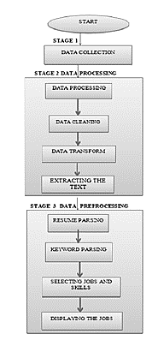

Data pre-processing is a process of preparing the raw data and making it suitable for a machine learning model. It is the first and crucial step while creating a machine learning model. When creating a machine learning project, it is not always a case that we come across the clean and formatted data. And while doing any operation with data, it is mandatory to clean it and put in a formatted way. So for this, we use data pre-processing task. A real-world data generally contains noises, missing values, and maybe in an unusable format which cannot be directly used for machine learning models. Data pre-processing is required tasks for cleaning the data and making it suitable for a machine learning model which also increases the accuracy and efficiency of a machine learning model.

**3.8. Exploratory Data Analysis:**

Exploratory Data Analysis refers to the critical process of performing initial investigations on data so as to discover patterns, to spot anomalies, to test hypothesis and to check assumptions with the help of summary statistics and graphical representations.

1. **Statistical Analysis**

The statistical analysis section provides crucial information on how the collected data and samples will be analysed to achieve the primary and secondary study aims. The statistical analysis section should have sufficient information for reviewing committees to be able to determine that the methodology is sound and valid for the planned analyses. For analysing the data statistically mean median and mode of different variables were calculated based on which average values and range of the variables are determined.

1. **Examining missing values:**

The missing values from the data are important to understand and examine in order to successfully manage data.  If the missing values are not handled properly by the researcher, then he/she may end up drawing an inaccurate inference about the data.  Due to improper handling, the result obtained by the researcher will differ from ones where the missing values are present.

1. **Null Values Imputation**

For various reasons, many real world datasets contain missing values, often encoded as blanks, NaNs or other placeholders. Such datasets however are incompatible with scikit-learn estimators which assume that all values in an array are numerical, and that all have and hold meaning. A basic strategy to use incomplete datasets is to discard entire rows and/or columns containing missing values. However, this comes at the price of losing data which may be valuable (even though incomplete). A better strategy is to impute the missing values, i.e., to infer them from the known part of the data

1. **Feature Engineering**

The data we received was not only extremely detailed, but often distributed across multiple files. or database tables. While we could easily describe its potential, we still had to manually prepare the data for the machine learning algorithms. These algorithms need data to be in a single table, with training examples in the rows and the explanatory variables (also known as features) in the columns. This data representation for machine learning is called the “feature matrix.” And “feature engineering” is the process of identifying and extracting predictive features in the complex data that enterprises typically work with. Feature engineering is challenging because it depends on leveraging human intuition to interpret implicit signals in datasets that machine learning algorithms use. Consequently, feature engineering is often the determining factor in whether a data science project is successful or not. Stanford Professor Andrew Ng accurately said, “…applied machine learning is basically feature engineering.

Chapter 4

**SYSTEM** **DESIGN**

**4.1 System Architecture**

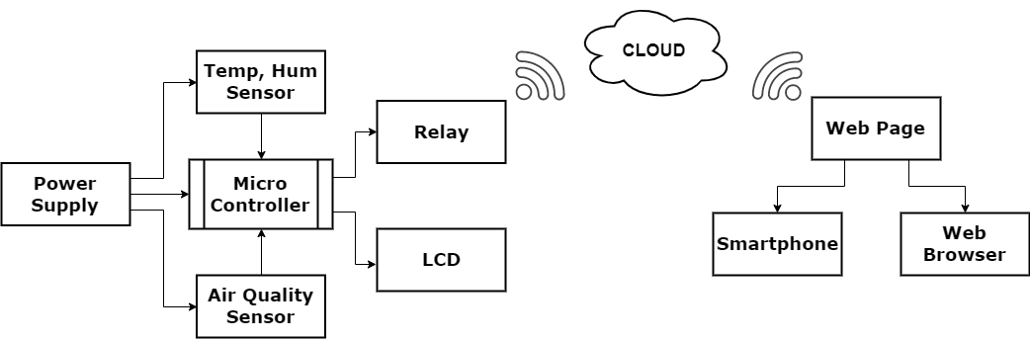

Fig. 4.1: System Architecture

**4.2 Data Flow Diagrams:**

**4.2.1 Level 0 data flow diagram**

1. The DFD is also called as bubble chart. It is a simple graphical formalism that Can be used to represent a system in terms of input data to the system, various processes carried out on this data, and the output data is generated by this system.

2. The data flow diagram (DFD) is one of the most important modelling tools. It is used to model the system components. These components are the system process, the data used by the process, an external entity that interacts with the system and the information shows in the system.

3. Figure 4.3 shows level 0 DFD which shows how the information moves through the system and how it is modified by a series of transformations. It is a graphical technique that depicts information flow and the transformations that are applied as data moves from input to output.

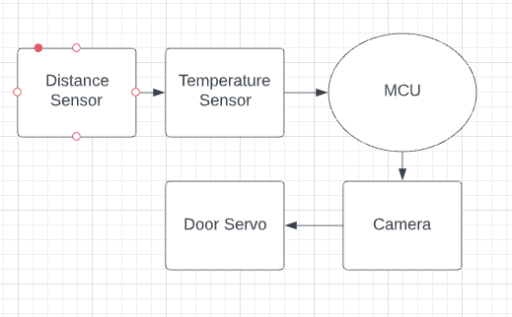

Fig. 4.3: DFD Level 0

**4.3 UML Diagrams**

**4.3.1 Use Case Diagram**

A use case diagram is a graphical representation of a user's interaction with the system and depicting the specifications of a use case. A use case diagram can show the different types of users of a system and the various ways in which they interact with the system. Use case diagrams are used to gather the requirements of a system including internal and external influences. These requirements are mostly design requirements. So when a system is analysed to gather its functionality use cases are prepared and actors are identified. The purposes of use case diagrams can be as follows:

* Used to gather requirements of a system.
* Used to get an outside view of a system.
* Identify external and internal factors influencing the system.
* Show the interaction among the actors.

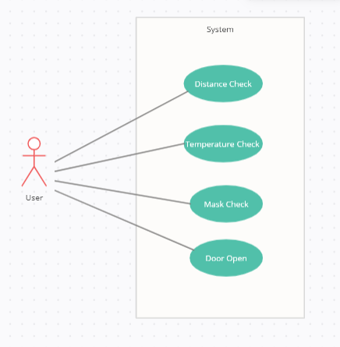

Fig. 4.5: use case

**4.3.2 State Diagram:**

The State diagram is a static diagram. It represents the static view of an application. State diagram is not only used for visualizing, describing and documenting different aspects of a system but also for constructing executable code of the software application. The State diagram describes the attributes and operations of a State and also the constraints imposed on the system.

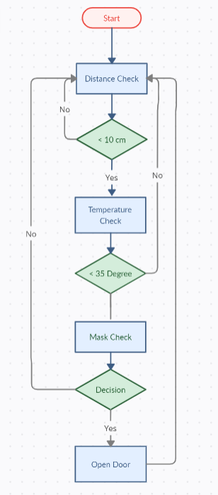

Fig. 4.6: State Diagram

**4.3.4** **Component** **Diagram**

A Component Diagram displays the structural relationship of components of a software system. These are mostly used when working with complex systems that have many components. Components communicate with each other using interfaces. The interfaces are linked using connectors.

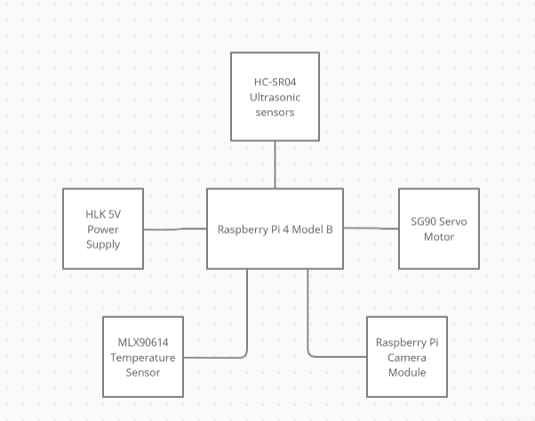

Fig. 4.8: Component Diagram

Chapter 5

**Project Plan**

## 

## **5.1 Project Estimates:**

### **5.1.1 Reconciled Estimates**

##### **Cost Estimate:**

Cost will estimate after completing the project that depend on time to complete the project and the hardware price respectively. Also, efforts required to complete.

**Time Estimates**

Time will depend on modules of project. Also, project plan of execution.

### **5.1.2Project Resources**

1. **Hardware Resources Required:**

* Raspberry Pi 4 Model B
* HC-SR04 Ultrasonic sensors
* MLX90614 Temperature Sensor
* Raspberry Pi Camera Module
* HLK 5V Power Supply

1. **Software Resources Required:**

* Operating System – Raspberry Pi OS
* Application – Python IDE

## **5.2 Risk Management:**

### **5.2.1Risk Identification**

For risks identification, review of scope document, requirements specifications and schedule are done. Answers to questionnaire revealed some risks. Each risk is categorized as per the categories mentioned in [**?**]. Please refer table **??** for all the risks. You can referee following risk identification questionnaire.

* Have top software and customer managers formally committed to support the project?  
  Answer: Yes, have top software and customer managers formally committed to support the project
* Are end-users enthusiastically committed to the project and the system/product to be built?  
  Yes, end-users enthusiastically committed to the project and the system/product to be built.
* Are requirements fully understood by the software engineering team and its customers?  
  Yes, are requirements fully understood by the software engineering team and its customers.
* Have customers been involved fully in the definition of requirements?  
  Yes, customers been involved fully in the definition of requirements.
* Are project requirements stable?  
  Answer: all project requirements are stable.
* Is the number of people on the project team adequate to do the job?  
  Yes, the number of people on the project team adequate to do the job.

### **5.2.2Risk Analysis**

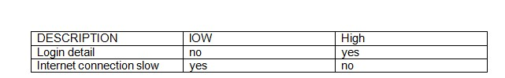

Table 5.1: Risk Analysis

Following are the details for each risk.

Risk ID 1

Risk Description 1

1.Human acts can change the result of the system.

Risk ID 2

2. The system must be continuously connected to the Power Supply for its working

## **5.4 Team Organization**

### **5.4.1 Team structure**

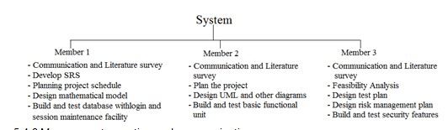

Fig. 5.4: Team structure

Chapter 6

**Project Implementation**

## 

## **6.1 Tools and Technologies Used**

### **6.1.1 Technology Description:**

Python programs are written in the Python Integrated Development Environment (IDE). Python IDE is a special software running on your system that allows you to write sketches (synonym for program in Python language) for different Python boards. The Python programming language is based on a very simple hardware programming language called processing, which is similar to the C language. After the sketch is written in the Python IDE, it should be uploaded on the Python board for execution.

### **6.2.2 Hardware Specifications:**

* Processor – Raspberry Pi 2.0
* RAM – 512 MB
* Memory Card – 16 GB
* Key Board - Standard Windows Keyboard
* Monitor - LCD (Liquid Crystal Display)

Chapter 7

**System Testing**

## **7.1 Types of Testing:**

### **7.1.1 Unit testing:**

Unit testing involves the design of test cases that validate that the internal program logic is functioning properly, and that program inputs produce valid outputs. All decision branches and internal code flow should be validated. It is the testing of individual software units of the application. It is done after the completion of an individual unit before integration. This is a structural testing, that relies on knowledge of its construction and is invasive. Unit tests perform basic tests at component level and test a specific business process, application, and/or system configuration. Unit tests ensure that each unique path of a business process performs accurately to the documented specifications and contains clearly defined inputs and expected results.

### **7.1.2 Integration testing:**

Integration tests are designed to test integrated software components to determine if they actually run as one program. Testing is event driven and is more concerned with the basic outcome of screens or fields. Integration tests demonstrate that although the components were individually satisfaction, as shown by successfully unit testing, the combination of components is correct and consistent. Integration testing is specifically aimed at exposing the problems that arise from the combination of components.

### **7.1.3 Functional test:**

Functional tests provide systematic demonstrations that functions tested are available as specified by the business and technical requirements, system documentation, and user manuals.

Functional testing is centred on the following items:

Valid Input: identified classes of valid input must be accepted.

Invalid Input: identified classes of invalid input must be rejected.

Functions: identified functions must be exercised.

Output: identified classes of application outputs must be exercised.

Systems/Procedures: interfacing systems or procedures must be invoked. Organization and preparation of functional tests is focused on requirements, key functions, or special test cases. In addition, systematic coverage pertaining to identify Business process flows; data fields, predefined processes, and successive processes must be considered for testing. Before functional testing is complete, additional tests are identified and the effective value of current tests is determined.

### **7.1.4 System Test:**

System testing ensures that the entire integrated software system meets requirements. It tests a configuration to ensure known and predictable results. An example of system testing is the configuration-oriented system integration test. System testing is based on process descriptions and flows, emphasizing pre-driven process links and integration points.

### **7.1.5 White Box Testing:**

White Box Testing is a testing in which in which the software tester has knowledge of the inner workings, structure and language of the software, or at least its purpose.

It is purpose. It is used to test areas that cannot be reached from a black box level.

### **7.1.6 Black Box Testing:**

Black Box Testing is testing the software without any knowledge of the inner workings, structure or language of the module being tested. Black box tests, as most other kinds of tests, must be written from a definitive source document, such as specification or requirements document, such as specification or requirements document. It is a testing in which the software under test is treated, as a black box. you cannot “see” into it. The test provides inputs and responds to outputs without considering how the software works.

### **7.1.7 Unit Testing:**

Unit testing is usually conducted as part of a combined code and unit test phase of the software lifecycle, although it is not uncommon for coding and unit testing to be conducted as two distinct phases.

### **7.1.8 Integration Testing:**

Software integration testing is the incremental integration testing of two or more integrated software components on a single platform to produce failures caused by interface defects. The task of the integration test is to check that components or software applications, e.g. components in a software system or – one step up – software applications at the company level – interact without error.

### **7.1.9 Acceptance Testing:**

User Acceptance Testing is a critical phase of any project and requires significant participation by the end user. It also ensures that the system meets the functional requirements. Test Results: All the test cases mentioned above passed successfully.

No defects encountered.

## **7.2 Test cases and Test Results:**

Testing of project problem statement using generated test data (using mathematical models, GUI, Function testing principles, if any) selection and appropriate use of testing tools, testing of UML diagram’s reliability.

Module-ID: -01

Modules to be tested: -System Working

1. When we plug the system to the ac power source.  
   Expected: It should Start the system and start sensing.
2. When the System is started it shall show the data on screen.  
   Expected: It should display data.
3. When the reset button is pressed the Resetting of system shall take place.  
   Expected: It should Reset the system
4. When the user come closer it shall take the users body temperature.  
   Expected: shall take the users body temperature.
5. When Temperature is normal it shall check user mask using the camera.

Expected: Check user mask

|  |  |  |  |  |
| --- | --- | --- | --- | --- |
| **Test Case ID** | **Description** | **Expected Result** | **Actual Result** | **Result** |
| 101 | Connect the system to the Power & sensor | System Connected | Connected successfully | P |
| 102 | System sense the user within the range | Sensed the user | Sensed the user within the range | P |
| 103 | Check the users Mask | Check the users mask using camera | Successfully Checked the users mask | P |
| 201 | Activate servo motor to open the door | Open the Door | Successfully opened the door | P |

Table 7.1: Test Cases

Chapter 9

**Results**

## **9.1 Screen Shots & Pictures:**

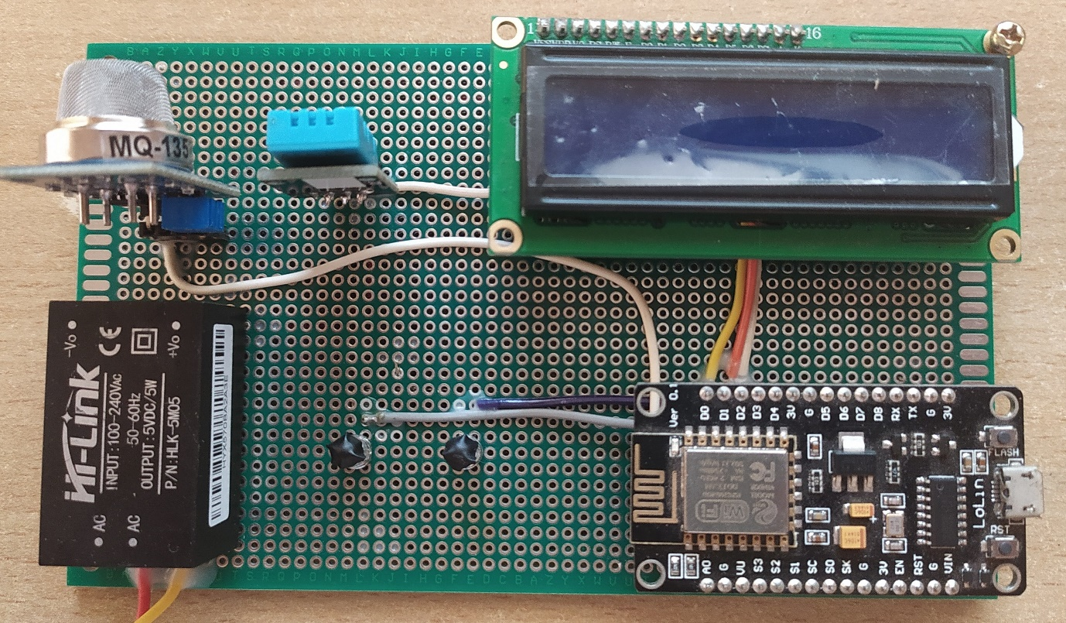

Fig. 9.1: System at Offline State

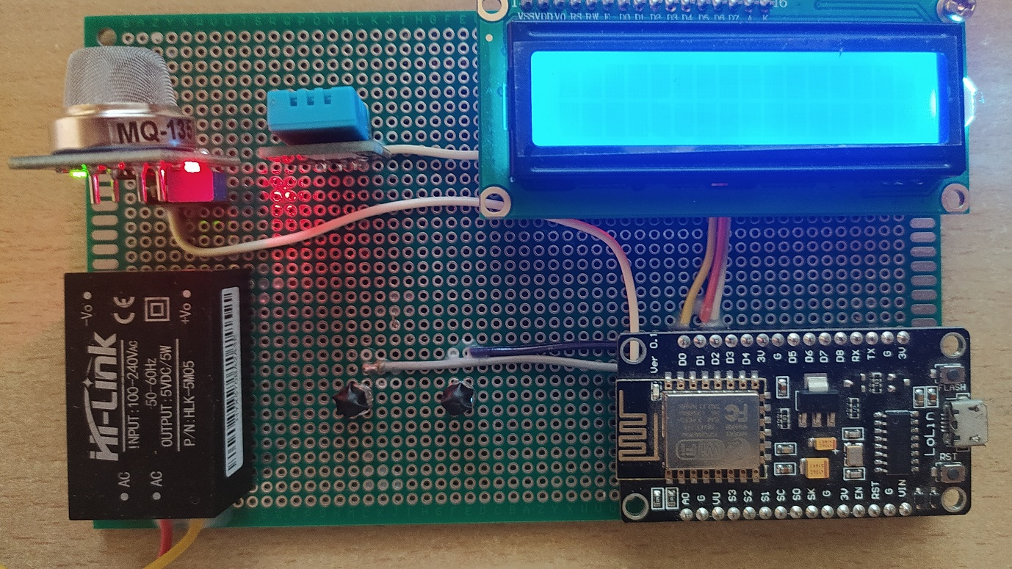

Fig. 9.2: System Plugged IN

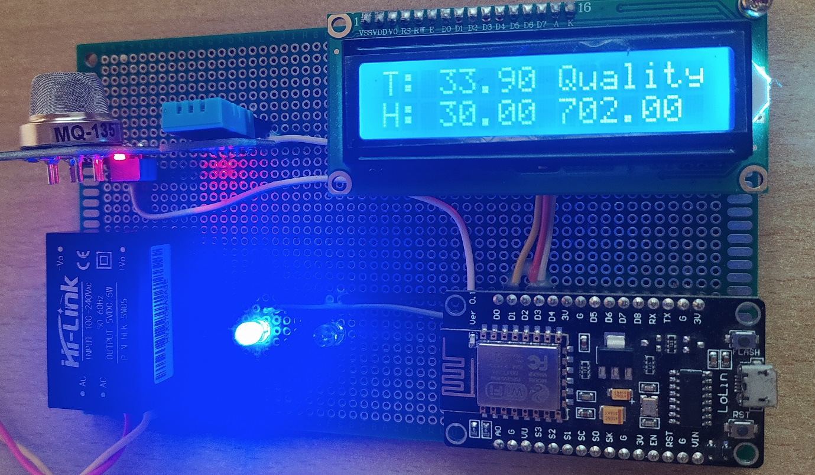

Fig. 9.3: Systems Initial state when connected to WIFI

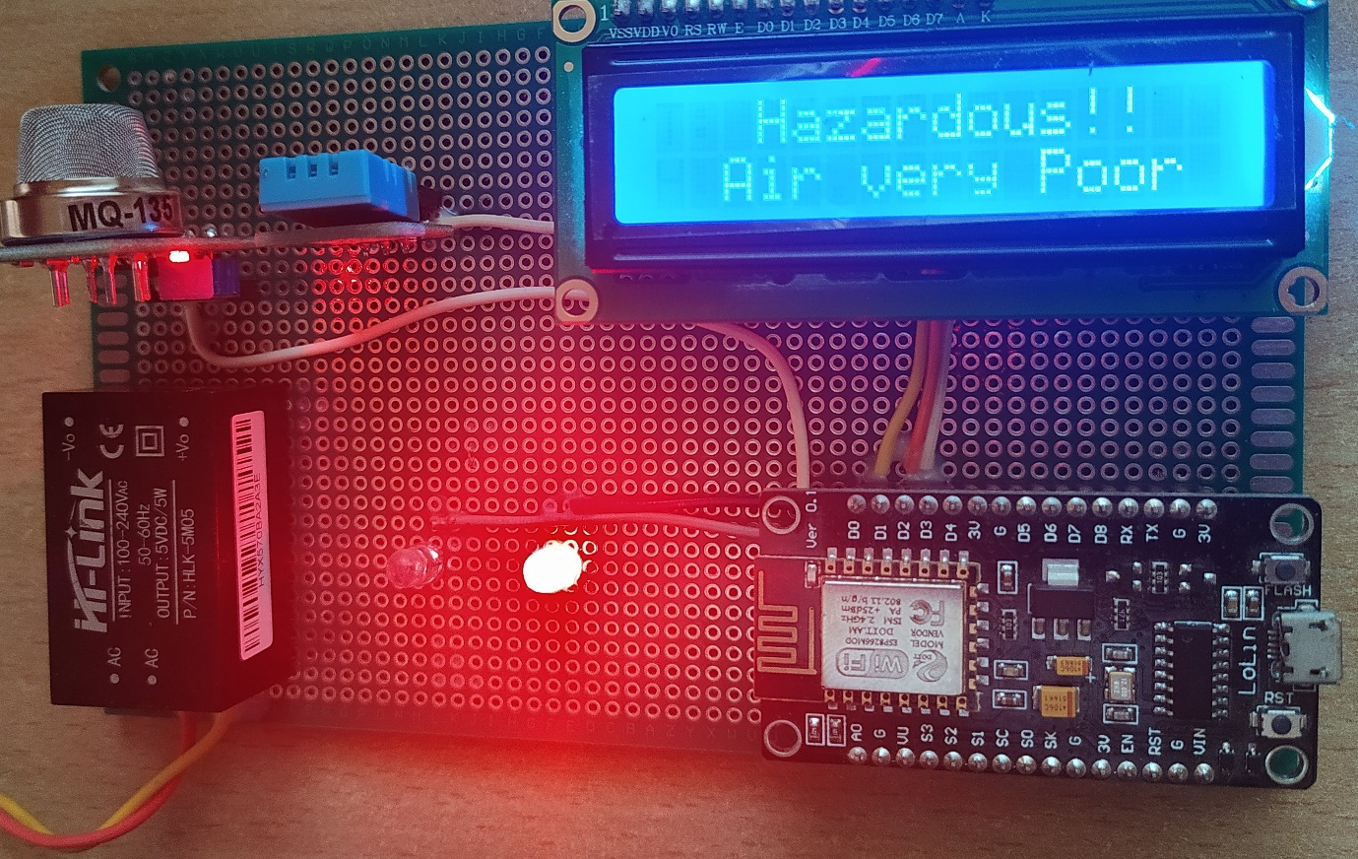

Fig. 9.4: System detected the Hazardous Atmosphere



Fig. 9.5: Mobile Application LOGO



Fig. 9.6: Applications Loading Screen

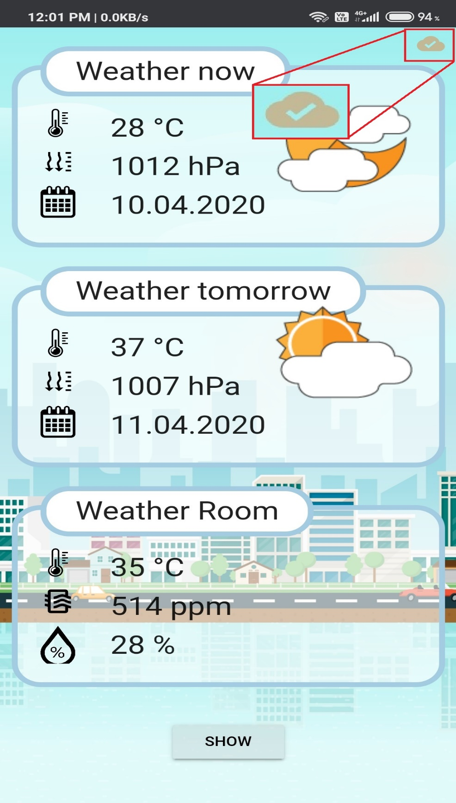

Fig. 9.7: System not synced with the Application

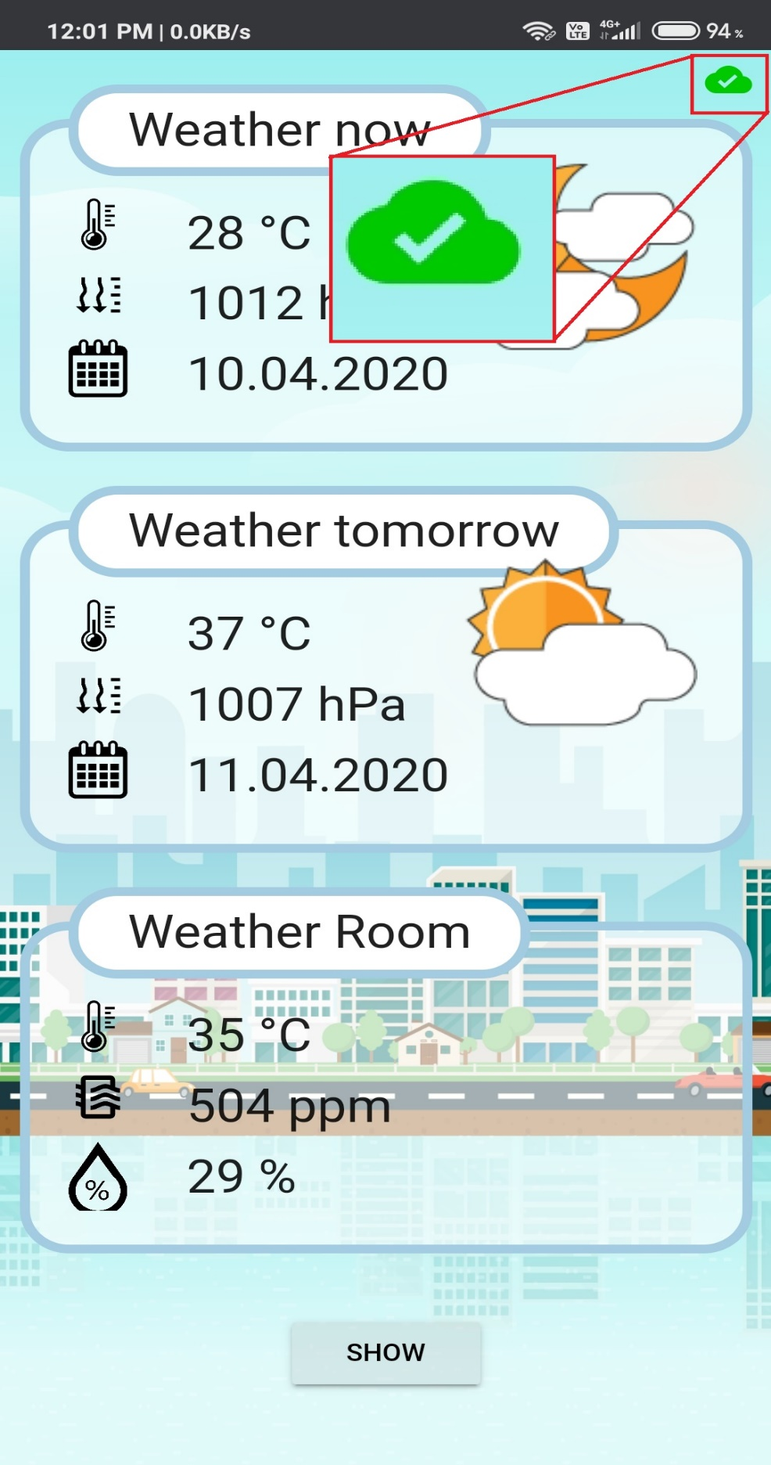

Fig. 9.8 System synced with the Application

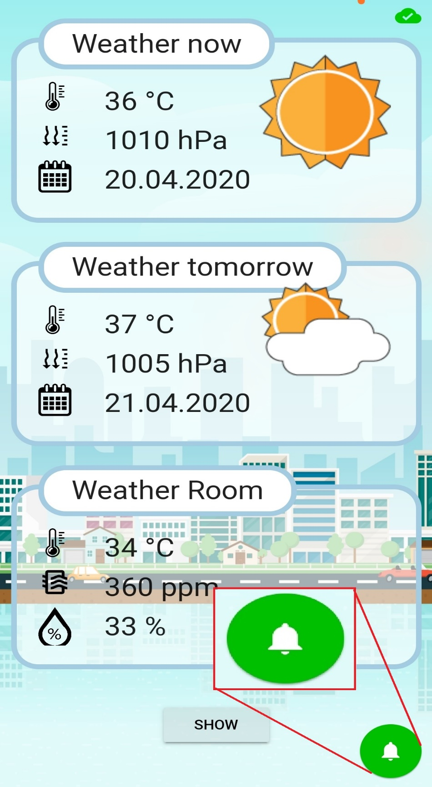

Fig. 9.8: Applications Notification Button

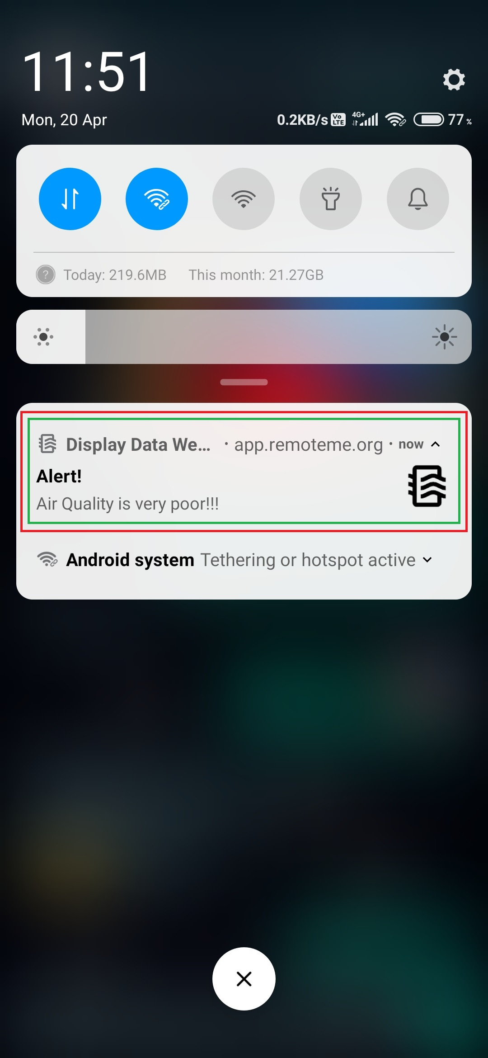

Fig. 9.9: ALERT Notification Screen

Chapter 10

**CONCLUSIONS**

## **10.1 Conclusion:**

In this Project, we design a system which help us to sense the Human Body Temperature in our Work place and will take the required action automatically. It will also result in save a lot of time and human energy. The system also help to make the work place more safer from the threat of COVID-19.It also mandates the use of Mask among the users and don’t allow the user if all the safety precautions are not followed. The system can be further more improved and some additional features can be added as a future scope

## **10.2 Application**

1. Face Mask Detection
2. Temperature Detection
3. Door Automation

## **10.3 Future Scope**

Furthermore, we can work on improved in security and accuracy without increasing MCU load.

**10.4 REFERENCES**

[1] W.H.O., “Coronavirus disease 2019 (covid-19): situation report, 205”. 2020

[2] “Coronavirus Disease 2019 (COVID-19) – Symptoms”, Centers for Disease Control and Prevention, 2020.

[3] “Coronavirus — Human Coronavirus Types — CDC”, Cdc.gov, 2020. [Online]. Available: https://www.cdc.gov/coronavirus/types.html. 2020.

[4] W.H.O., “Advice on the use of masks in the context of COVID-19: interim guidance”, 2020.

[5] M. Jiang, X. Fan and H. Yan, “RetinaMask: A Face Mask detector”, arXiv.org, 2020. [Online]. Available: https://arxiv.org/abs/2005.03950. 2020.

[6] B. Suvarnamukhi and M. Seshashayee, “Big Data Concepts and Techniques in Data Processing”, International Journal of Computer Sciences and Engineering, vol. 6, no. 10, pp. 712-714, 2018. Available: 10.26438/ijcse/v6i10.712714.

[7] F. Hohman, M. Kahng, R. Pienta and D. H. Chau, “Visual Analytics in Deep Learning: An Interrogative Survey for the Next Frontiers,” in IEEE Transactions on Visualization and Computer Graphics, vol. 25, no. 8, pp. 2674-2693, 1 Aug. 2019, doi: 10.1109/TVCG.2018.2843369.

[8] C. Kanan and G. Cottrell, “Color-to-Grayscale: Does the Method Matter in Image Recognition?”, PLoS ONE, vol. 7, no. 1, p. e29740, 2012. Available: 10.1371/journal.pone.0029740.

[9] Opencv-python-tutroals.readthedocs.io. 2020. Changing Colorspaces — Opencv-Python Tutorials 1 Documentation. [online] Available at:https://opencv-python-tutroals.readthedocs.io/en/latest/py tutorials/ py imgproc/py colorspaces/py colorspaces.html. 2020.

[10] M. Hashemi, “Enlarging smaller images before inputting into convolutional neural network: zero-padding vs. interpolation”, Journal of Big Data, vol. 6, no. 1, 2019. Available: 10.1186/s40537-019-0263-7 . 2020.